Booking Enquiries

# Code

You will find further instructions and code in WEDE5010 / Waverly Guest House / ExpressiveWeb code library / Forms / form code.txt

# H1: Booking Enquiries

Please submit your enquiry using the form below. We will respond within 24 hours.  
Alternatively, call us on 021 555 5555.

Items with a * are required.

|  |  |  |
| --- | --- | --- |
| **Label** | **Type** | **Properties** |
| First name | Text | Required |
| Last name | Text | Required |
| Email | Text | Required |
| Phone | Text |  |
| Room required | Select list | Required  Options:  Cosy Couple  Sumptuous Suite  Family Fare |
| Arrival date | Text | Required  Calendar popup |
| Departure date | Text | Required  Calendar popup |
| Special requests or questions | Textarea |  |
| Send | Submit button | Triggers validation |

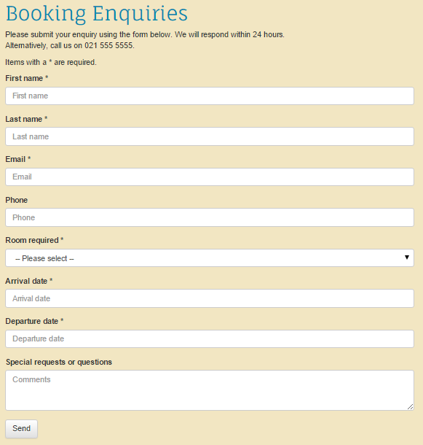

# Sidebar

Main image – waverly-booking.png

Alt text – Book now!

## Testimonial

Thanks you so much for the tremendous hospitality. You made our anniversary special – arrangements for the flowers, chocolates, champagne. Thank you again.

- Lihle

Pic = testimonial-lihle.png